**MINISTRY OF EDUCATION AND TRAINING**

**DUY TAN UNIVERSITY**



**RENTING HELPER -**

**A SUPPORT SYSTEM FOR**

**FINDING HOUSE FOR RENT ON ANDROID OS**

# 🙠🖎🕮✍🙢

**USER INTERFACE DESIGN DOCUMENT**

**TEAM MEMBERS**

1. **NGUYEN LUONG HOANG - 1560**
2. **NGUYEN NGOC VU - 1579**
3. **HUA THI THONG - 6419**
4. **NGUYEN DINH THI NGOC DIEP - 1558**
5. **TRAN VAN THANH - 1571**

**Da Nang, Feb - 2018**

|  |  |  |  |  |
| --- | --- | --- | --- | --- |
| **PROJECT INFORMATION** | | | | |
| **Project Acronym** | RH | | | |
| **Project Title** | Renting helper - a support system for finding house for rent on Android OS | | | |
| **Start Date** | 01– Feb – 2018 | **End Date** | 15 – Mar – 2018 | |
| **Lead Institution** | Department Of Information Technology, Duy Tan University | | | |
| **Project Mentor** | Thi S. T. TRINH  Email: trinhsutruongthi@gmail.com  Phone: 0905.723.278 | | | |
| **Product Owner & Contact Detail** | Diep D. T. N. NGUYEN  Email: diep.nguyendtngoc@gmail.com  Phone: 0905.517.760 | | | |
| **Partner Organization** | Duy Tan University | | | |
| **Project Manager &Scrum Master** | Hoang L. NGUYEN | luonghoangdn92@gmail.com | | 0934.799.890 |
| **Team Members** | Vu N. NGUYEN | nnvu92@gmail.com | | 0906.351.761 |
| Thong T. HUA | huathithong93@gmail.com | | 01683.698.807 |
| Thanh V. TRAN | tranvanthanh217@gmail.com | | 01647.187.783 |
| Diep D. T. N. NGUYEN | [diep.nguyendtngoc@gmail.com](mailto:diep.nguyendtngoc@gmail.com) | | 0905.517.760 |

|  |  |  |  |  |
| --- | --- | --- | --- | --- |
| **DOCUMENT NAME** | | | |  |
| **Document Title** | User Interface Design Document | | |  |
| **Author(s)** | Diep D. T. N. NGUYEN | | |  |
| **Role** | Team member | | |  |
| **Date** | 14 – Feb – 2018 | **File name:** | [RH]User Interface Design-Sprint1-ver.1.0.docx |  |
| **URL** |  | | |  |
| **Access** |  | | |  |

|  |  |  |  |
| --- | --- | --- | --- |
| **REVISION HISTORY** | | | |
| **Version** | **Person(s)** | **Date** | **Description** |
| **1.0** | Diep D. T. N. NGUYEN | 14 – Feb – 2018 | Create document. |

|  |  |  |  |
| --- | --- | --- | --- |
| **Document Approval**  The following signatures are required for approval of this document | | | |
| **Mentor** | Thi S. T. TRINH | **Signature:** |  |
| **Date:** |  |
| **Product Owner** | Diep D. T. N. NGUYEN | **Signature:** |  |
| **Date:** |  |
| **Scrum Master** | Hoang L. NGUYEN | **Signature:** |  |
| **Date:** |  |
| **Team Member(s)** | Diep D. T. N. NGUYEN | **Signature:** |  |
| **Date:** |  |
| Vu N. NGUYEN | **Signature:** |  |
| **Date:** |  |
| Thanh V. TRAN | **Signature:** |  |
| **Date:** |  |
| Thong T. HUA | **Signature:** |  |
| **Date:** |  |

TABLE OF CONTENTS

1. INTRODUCTION 1

1.1. Purpose 1

1.2. Scope 1

2. LIST OF INTERFACES FOR SPRINT 1 1

3. DESCRIBE USER INTERFACES FOR SPRINT 1 2

3.1. Register 2

3.2. Login 4

3.3. Navigation 6

3.4. Choose city 7

LIST OF TABLES

Table 2.1: List of Interfaces for Sprint 1 1

Table 3.1: Register 3

Table 3.2: Login 4

Table 3.3: Show Navigation 6

Table 3.4: Choose city 7

LIST OF FIGURES

Figure 3.1: Register 2

Figure 3.2: Login 4

Figure 3.3: Navigation 6

Figure 3.4: Choose city 7

1. **INTRODUCTION**
   1. **Purpose**

This document describes the interfaces design of Renting Helper System.

* 1. **Scope**
* This document provides an overview of the stages and modules of the system.
* Create complete interfaces and describe them clearly.

1. **LIST OF INTERFACES FOR SPRINT 1**

###### Table 2.1: List of Interfaces for Sprint 1

|  |  |  |  |
| --- | --- | --- | --- |
| **User Interface ID** | **UI Name** | **Description** | **Notes** |
| UI-01 | Navigation | This screen is the main menu of the application | N/A |
| UI-02 | Register | This screen is the page to register new user | N/A |
| UI-03 | Login | This screen is used to log in to the system | N/A |
| UI-04 | Choose city | This screen is used to choose city location to find renting house | N/A |

1. **DESCRIBE USER INTERFACES FOR SPRINT 1**

4. 1. **Register**

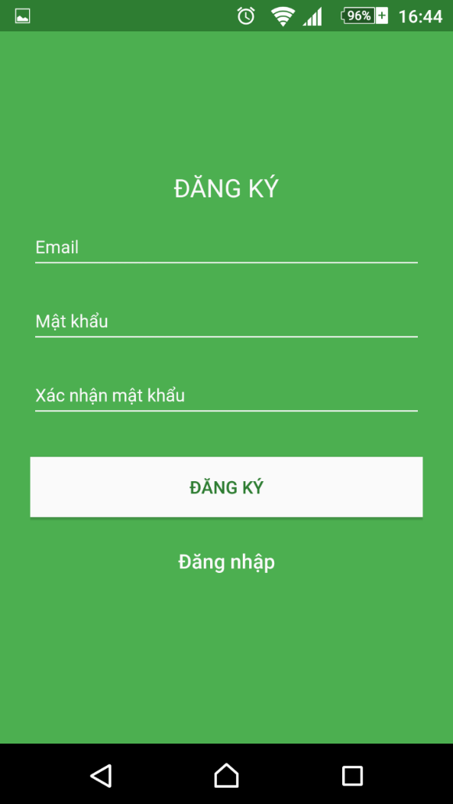

##### Figure 3.1: Register

###### Table 3.1: Register

|  |  |  |  |  |  |  |  |
| --- | --- | --- | --- | --- | --- | --- | --- |
| **Screen** | | | Register | | | | |
| **Description** | | | The form where user registers new account to use the system | | | | |
| **Screen Access** | | |  | | | | |
| **Screen Content** | | | | | | | |
| **Item ID** | **Item Name** | | **Type** | | **Data** | **Description** | |
| 1.1 | User’s email, password and confirmed password | | Edit Text | |  | User’s email, password and confirmed password textboxes | |
| 1.2 | Login and register buttons | | Button | |  | Login and register buttons | |
| 1.3 | Register | | Text View | |  | Register label | |
| **Screen Actions** | | | | | | | |
| **Action Name** | | **Description** | | **Success** | | | **Failure** |
| Show register form | | 1. Access the application  2. Click Register button  3. Input data and click Register button | | Show register form and create account successfully | | | Can’t register account |

3. 2. **Login**

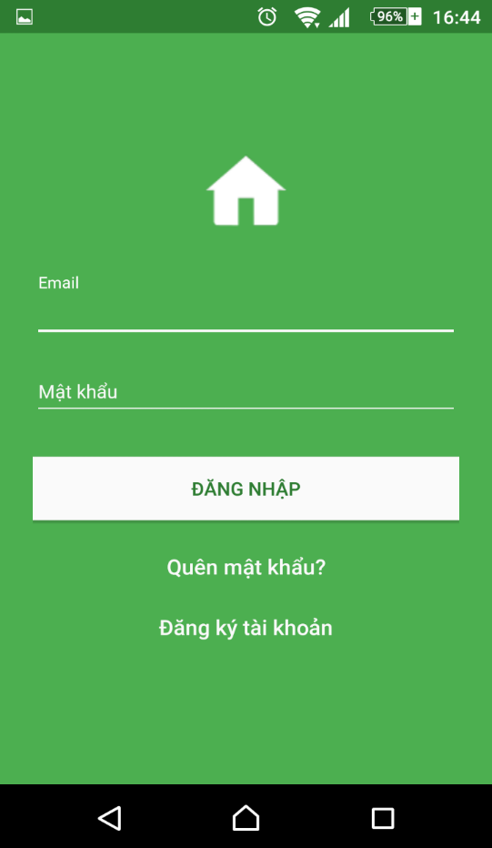

##### Figure 3.2: Login

###### Table 3.2: Login

|  |  |  |  |  |  |  |  |
| --- | --- | --- | --- | --- | --- | --- | --- |
| **Screen** | | | Login | | | | |
| **Description** | | | Where user logs in to use the system | | | | |
| **Screen Access** | | |  | | | | |
| **Screen Content** | | | | | | | |
| **Item ID** | **Item Name** | | **Type** | **Data** | | **Description** | |
| 2.1 | User’s email and password | | Edit Text |  | | User’s email and password textboxes | |
| 2.2 | Login | | Button |  | | Login button | |
| 2.3 | Forget password | | Text View |  | | Forget password hyperlink | |
| 2.4 | Register | | Hyperlink |  | | Register hyperlink | |
| **Screen Actions** | | | | | | | |
| **Action Name** | | **Description** | | | **Success** | | **Failure** |
| Login | | 1. Access the application  2. Input email and password  3. Click Login button | | | Show house for rent lists | | Can’t log in |

3. 3. **Navigation**

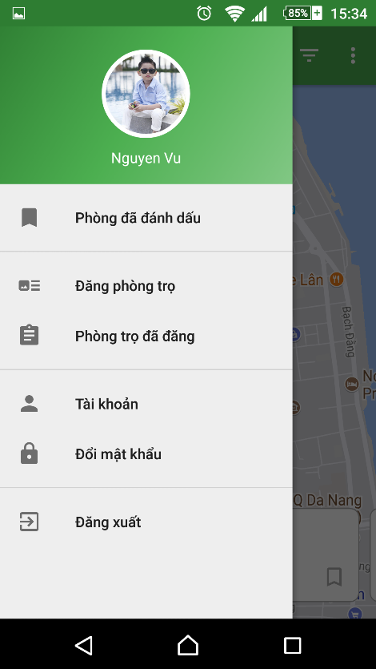

##### Figure 3.3: Navigation

###### Table 3.3: Show Navigation

|  |  |  |  |  |  |  |  |
| --- | --- | --- | --- | --- | --- | --- | --- |
| **Screen** | | | Navigation | | | | |
| **Description** | | | Show navigation of the application | | | | |
| **Screen Access** | | | Login | | | | |
| **Screen Content** | | | | | | | |
| **Item ID** | **Item Name** | | **Type** | | **Data** | **Description** | |
| 3.1 | Marked houses | | Menu | |  | Save list of houses user marked | |
| 3.2 | Post house for rent | | Menu | |  | Post your house’s information to system for renting | |
| 3.3 | Posting history | | Menu | |  | Your history of posting house for rent | |
| 3.4 | Account | | Menu | |  | Manage your user account | |
| 3.5 | Change password | | Menu | |  | Change password | |
| 3.6 | Log out | | Menu | |  | Log out of the system | |
| 3.7 | User’s avatar | | Image | |  | User’s avatar | |
| 3.8 | User’s name | | Text View | |  | User’s name | |
| **Screen Actions** | | | | | | | |
| **Action Name** | | **Description** | | **Success** | | | **Failure** |
| Access application | | Log in to the application on Android device and click the top left button | | Access the application successfully, show navigation | | | Can’t access the application, also can’t see navigation |

3. 4. **Choose city**

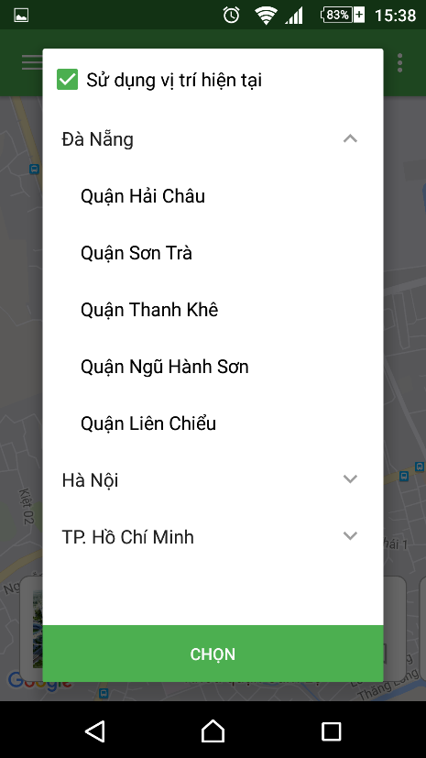

##### Figure 3.4: Choose city

###### Table 3.4: Choose city

|  |  |  |  |  |  |  |
| --- | --- | --- | --- | --- | --- | --- |
| **Screen** | | | Choose city | | | |
| **Description** | | | Choose city location to find renting house | | | |
| **Screen Access** | | | Login | | | |
| **Screen Content** | | | | | | |
| **Item ID** | **Item Name** | | **Type** | **Data** | **Description** | |
| 3.1 | City | | Expandable list view |  | Choose city | |
| 3.2 | District | | Expandable list view |  | Choose district of that city | |
| 3.3 | Select | | Button |  | Select | |
| 3.4 | Choose current location | | Check box + Text View |  | Choose current location | |
| **Screen Actions** | | | | | | |
| **Action Name** | | **Description** | | **Success** | | **Failure** |
| Access application | | Log in to the application on Android device and choose city then choose district and click Continue button | | Access the application successfully, show list of house | | Can’t access the application, also can’t show list of house |